

Our priorities and our asks for the next Scottish Government
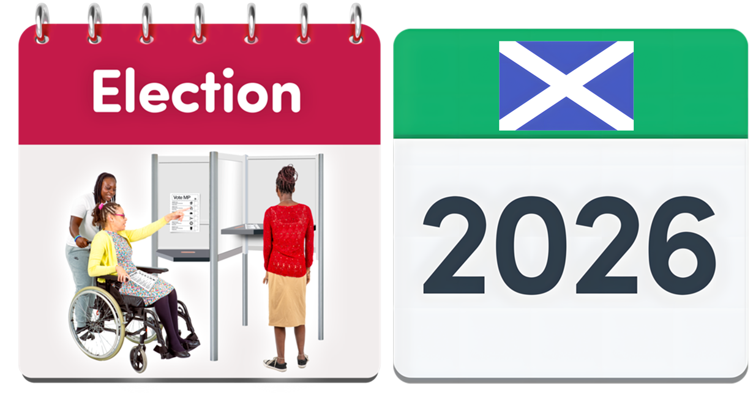



Easy Read Part 3


Racism and people treated unfairly because of their race
 | Race means someone’s ethnic group, skin colour or where they come from.  Racism means being treated unfairly because of your racial or ethnic group.
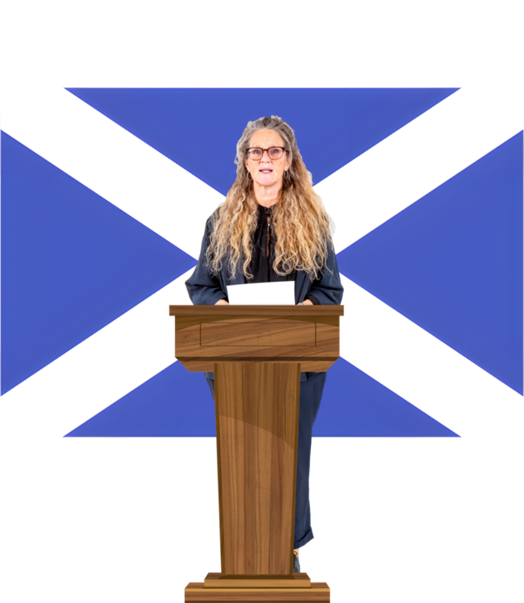 | The next Scottish Government must make sure that these 5 things happen to make sure everyone is treated fairly, whatever their race.
 | 1. Give the right funding and support for a Hate Crime Delivery Plan.  This will help us to spot and report hate crime that is about someone’s race.
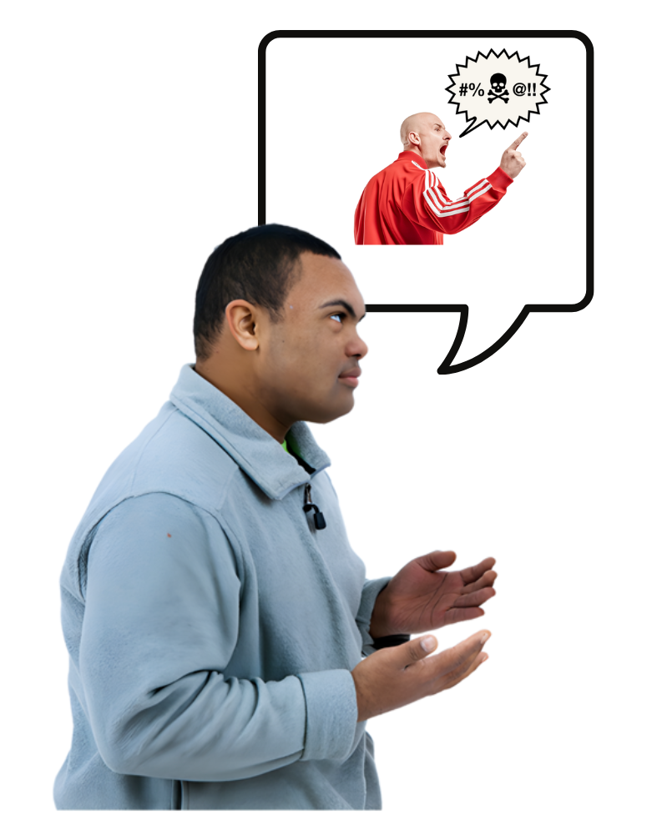 | A hate crime is when someone does something to hurt you because of who you are or who they think you are.  The criminal thinks you are different from them and hates you because of that difference.
 | A delivery plan is a document to say what action will happen and who will do it.
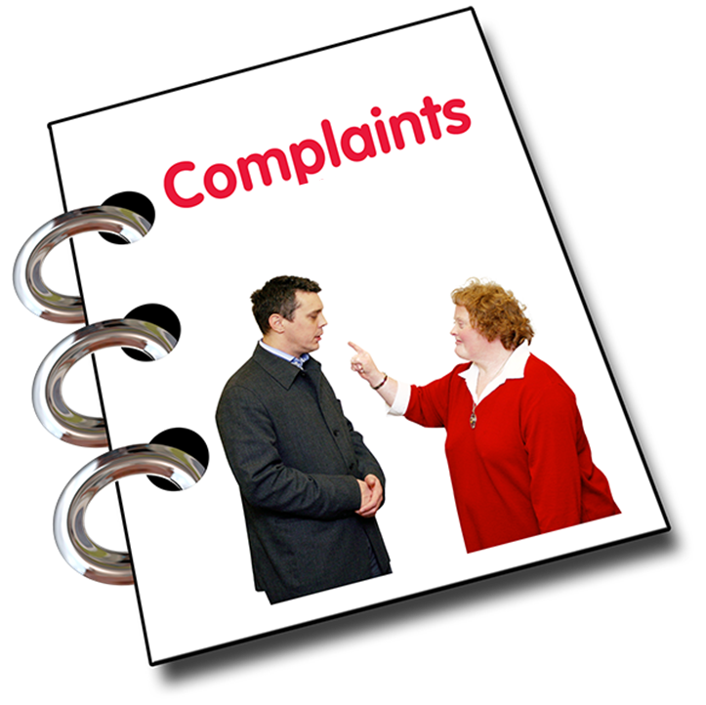 | 2. Make a good complaints policy for public health and other public services.  A complaint is when a person says or writes that they are not happy about something.  This will help find out about people’s experiences of racism.
 | 3. Collect information in a better way so that we can see how racism affects people.  Especially when they may experiencing other things too.
 | 4. Make a national action plan to stop some people being treated unfairly because of their race when they:  - apply for jobs  - want to stay in a job  - want to have a job with the same number of hours each week  - are paid low wages
 | A national action plan is a document that says what will happen right across Scotland.
 | 5. Make a national action plan to share good ways to stop racism happening in places like:  - nurseries  - schools  - colleges  - universities

Migrant Rights
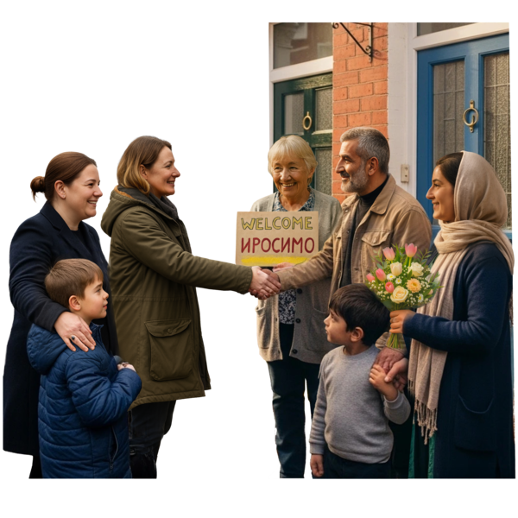 | A migrant is a person who moves from one country to another, often for reasons like:  - work  - education  - to be with family
 | The next Scottish Government must make sure that these 6 things happen for migrants to have better rights in Scotland.
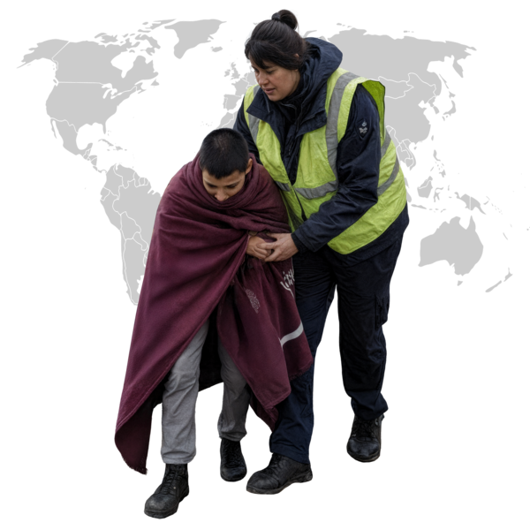 | 1. Work with the UK government to make sure that all refugee children and asylum seeking children have the right to reach their families in the UK.
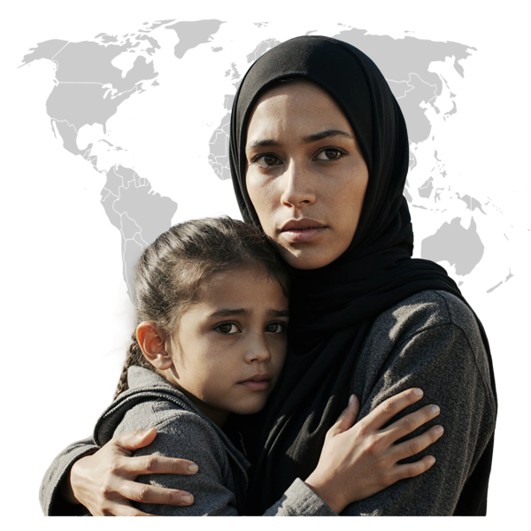 | In this document refugee and asylum seekers mean people who have fled their home country because of war or other things harming them or their family.  They come to another country for protection.
 | 2. Spend more money on projects which help people from different races to get things like:  - homes  - healthcare  - community life
 | 3. Give refugees and asylum seekers free travel using public transport like buses and trains.
 | 4. Work together with other teams and organisations to listen to the experiences and views of refugee and asylum seekers.  Put these things into policies and planning in many different areas, like education and jobs.
 | 5. Work with the UK government to change the rule that says that some refugees and asylum seekers cannot get most UK benefits or help with housing.
 | 6. Show strong leadership on these things:  - acts of extreme violence and cruelty against large groups of people  - working to stop large groups of people being killed or hurt  - supporting the communities affected when these crimes happen

Access to the justice system
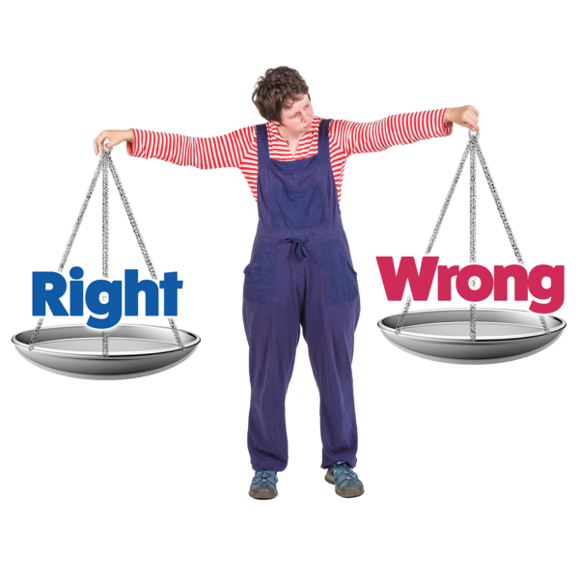 | Justice means treating people fairly by law.  The justice system means the people and organisations that deal with crime including the police and courts.
 | The next Scottish Government must make sure that these 8 things happen.
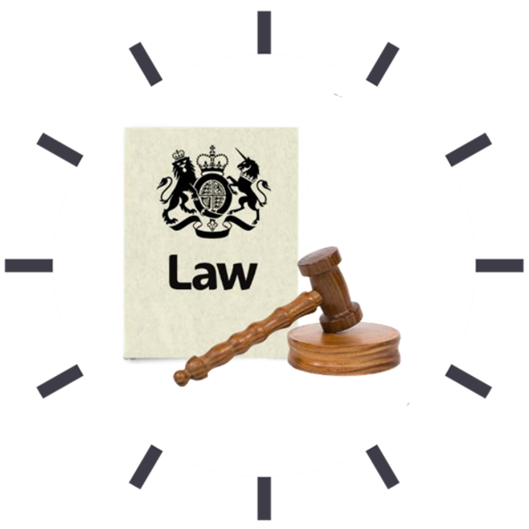 | 1. Make new laws for the legal aid system which carry on work already done.
 | The legal aid system in Scotland is a public service that helps people who cannot afford things like a solicitor.  A solicitor is an expert who gives advice about the law.
 | 2. Offer more legal aid.
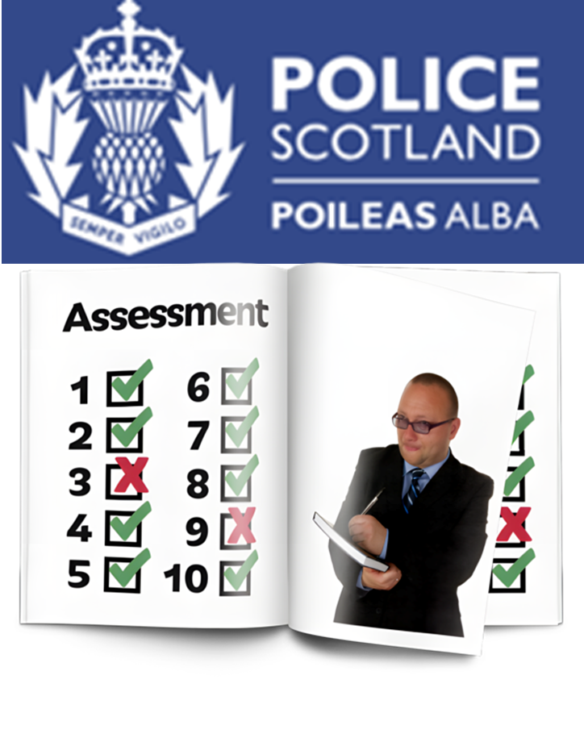 | 3. Make sure that Police Scotland write impact assessments about human rights.  An impact assessment checks how plans and policies affect people.
 | These impact assessments should look at all new policies and action about criminal justice.
   | 4. Give enough money to do criminal justice social work and show how it helps stop crimes happening again.  Criminal justice social work helps people in the criminal justice system so they are less likely to turn to crime again.
 | Give enough money so that community justice services can happen and show how they help stop crimes happening again.
 | Community justice services are programmes and projects which help people to feel better about themselves and not turn to crime again.
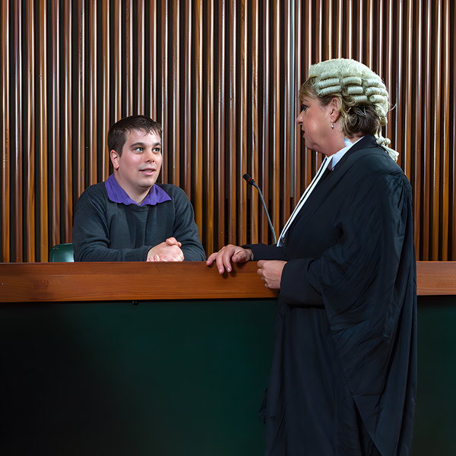 | 5. Write a national plan to catch up with court cases so there is no long waiting list.  A court case is where a judge or jury hears evidence and decides:  - what happens next  - if someone has broken the law
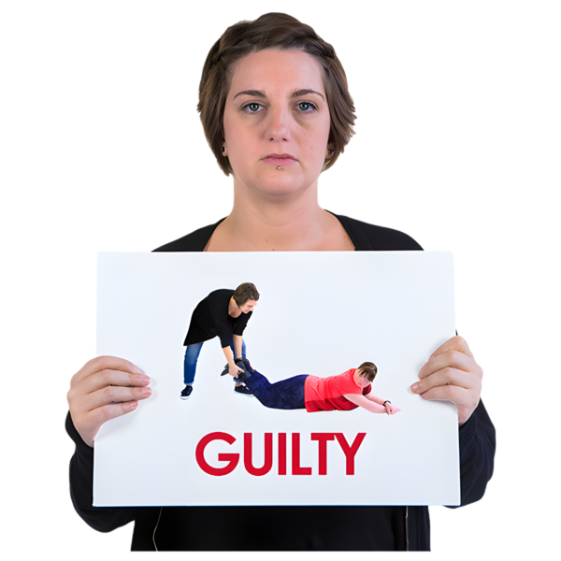 | 6. Change the guidance for deciding a criminal’s sentence.  A sentence means the punishment given to a person who has been found guilty of a crime.
 | The guidance should:  - make it possible to choose a sentence that best suits the person  - support them to make better choices
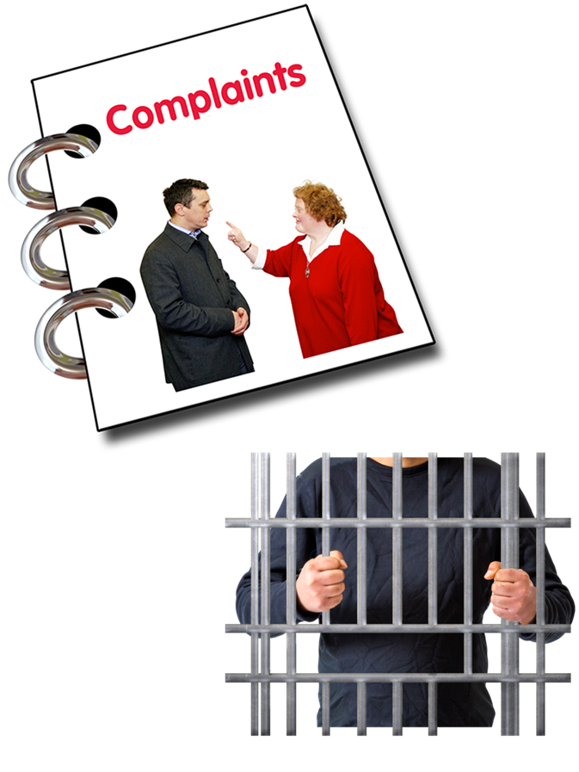 | 7. Make changes in the way complaints are handled for prisoners.  These changes were suggested by the Scottish Human Rights Consortium.
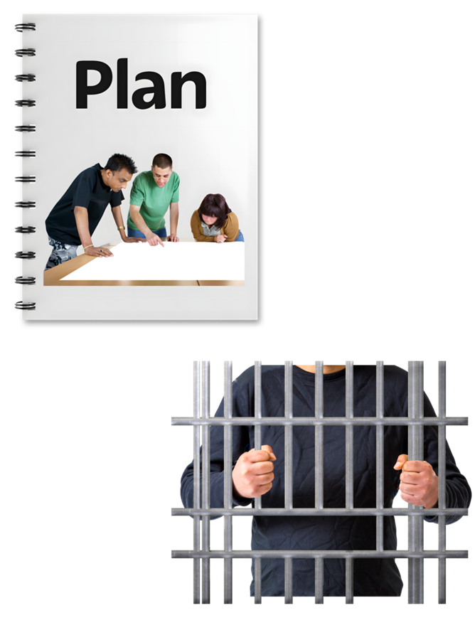 | 8. Make an action plan about human rights for families and children who are affected by a family member being in prison.

Rights about the environment
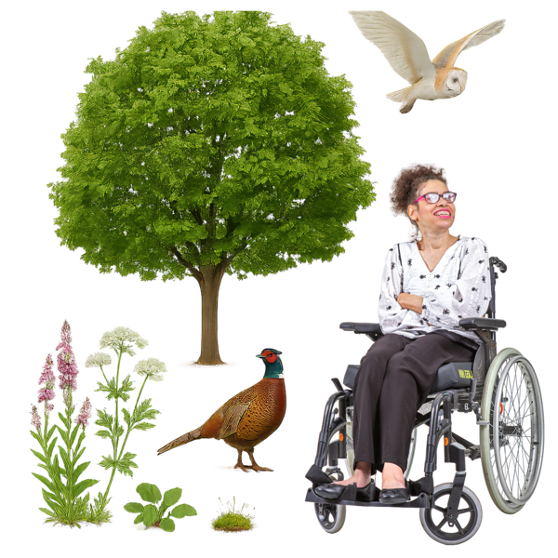 | Environment means everything around us like:  - air  - water  - land  - plants  - animals
 | The next Scottish Government must make sure that these 5 things happen so that everyone has their human rights for their environment.
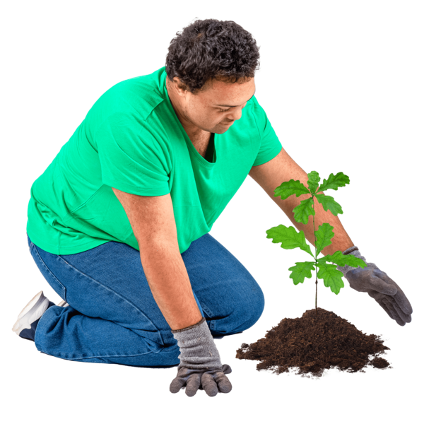 | 1. Put this right into Scots law:  The right to a healthy environment.
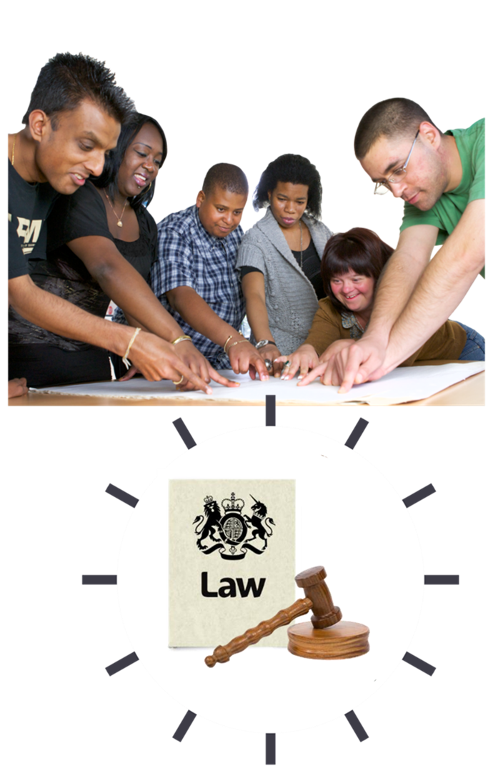 | Make sure that this new law is understood by organisations like:  - businesses which have wastes like chemicals, waste water and gases  - hospitals  - local councils
  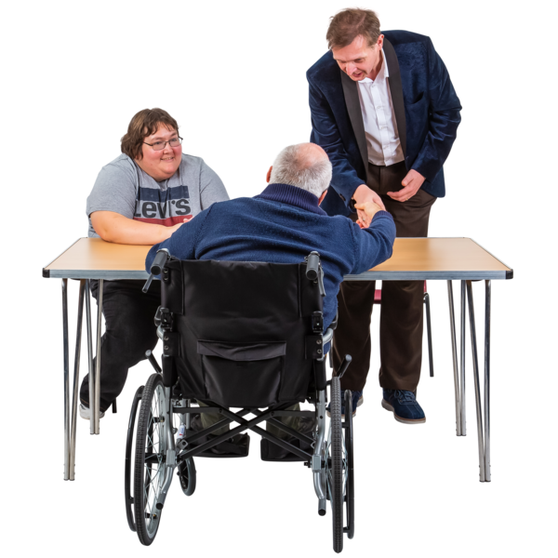 | 2. Make sure that access to justice:  - is fair  - happens quickly enough  - is not too expensive  These are things that were recommended by an agreement called the Aarhus Convention.
 | The Aarhus Convention says that the public should have rights to get involved in protecting the environment.
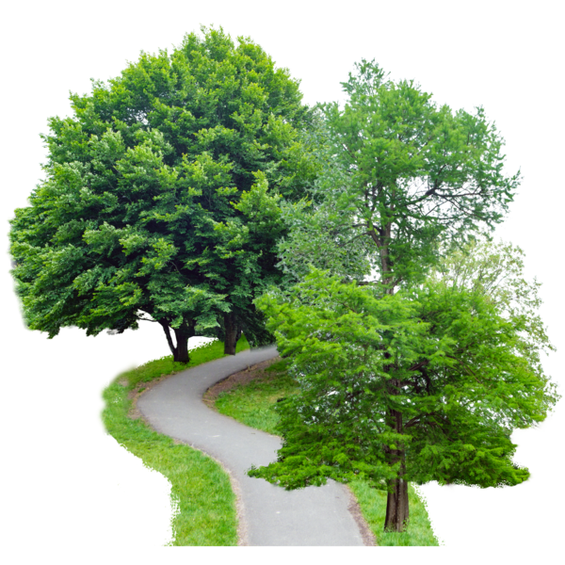 | 3. Make poorer areas better, cleaner and greener.  Make it easier for people in these areas to get to green spaces like parks and gardens.
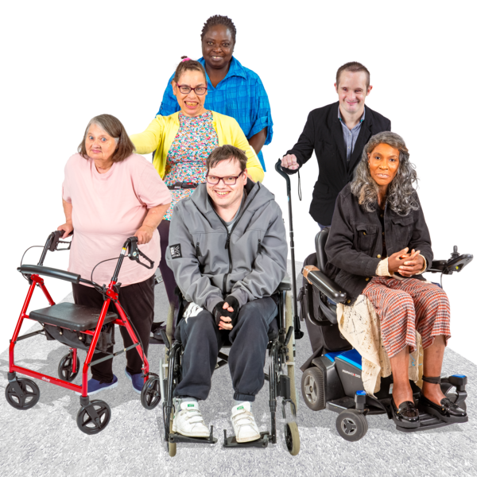 | Give groups of people who are often left out more chances to help make decisions about their area.
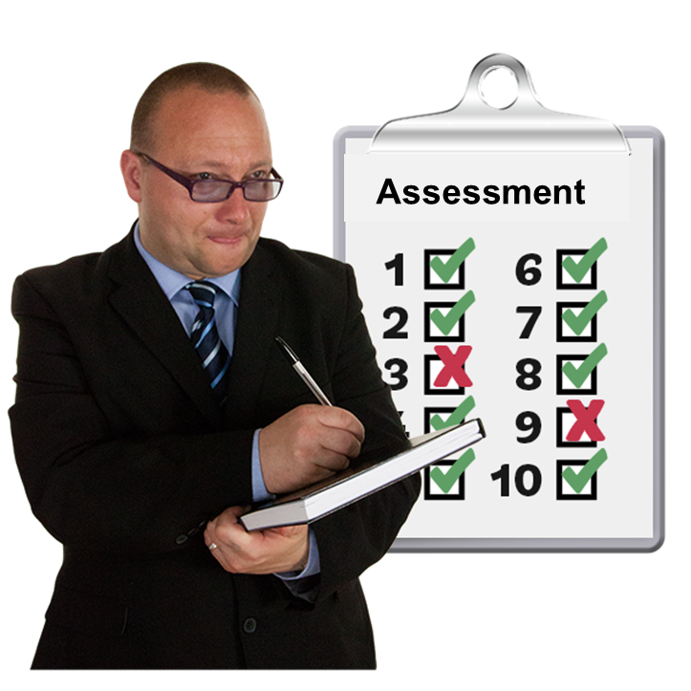 | 4. Choose a clear way to measure:  - how clean, green and positive an environment is  - where an environment is not good enough
 | 5. Make sure that all work is clear and open for everyone to see.  Do this by working with lots of different types of organisations.

More information
 | This is the end of Part 3.  If you want to know more about our asks and priorities please email admin@hrcscotland.org



