

Our priorities and our asks for the next Scottish Government
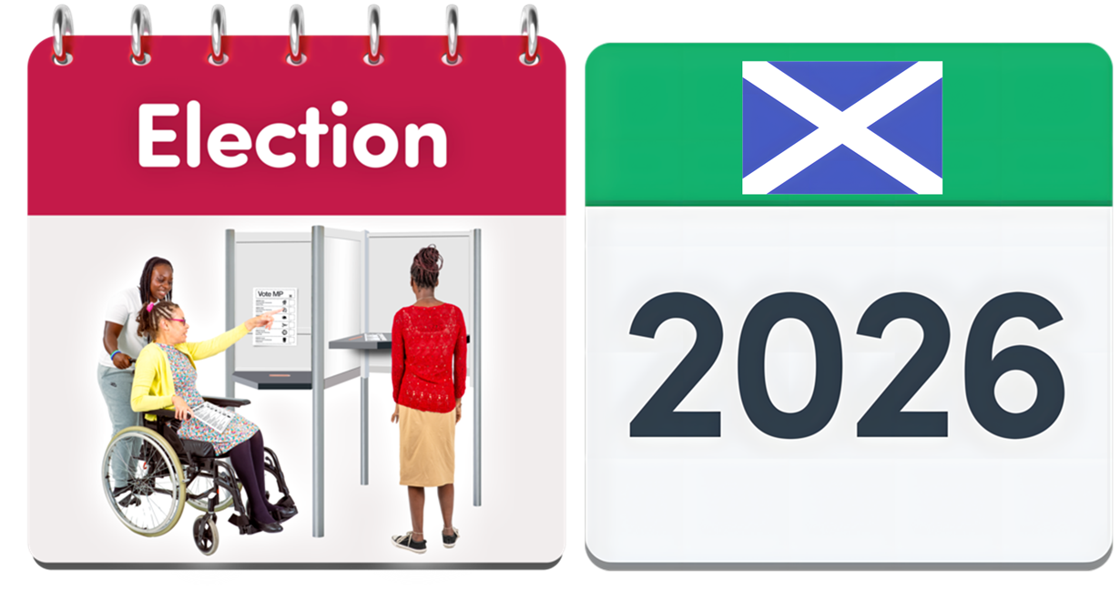
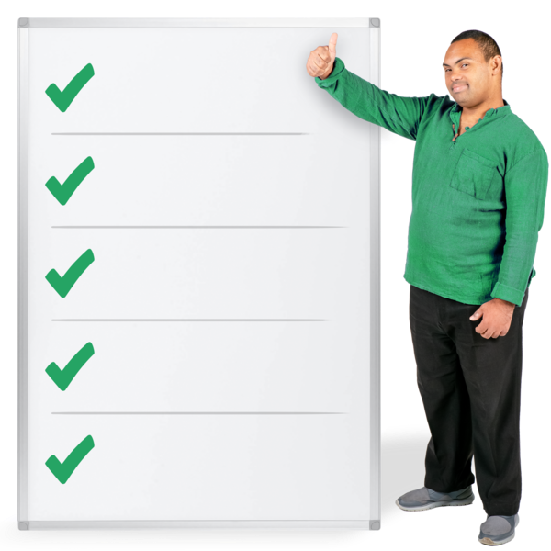

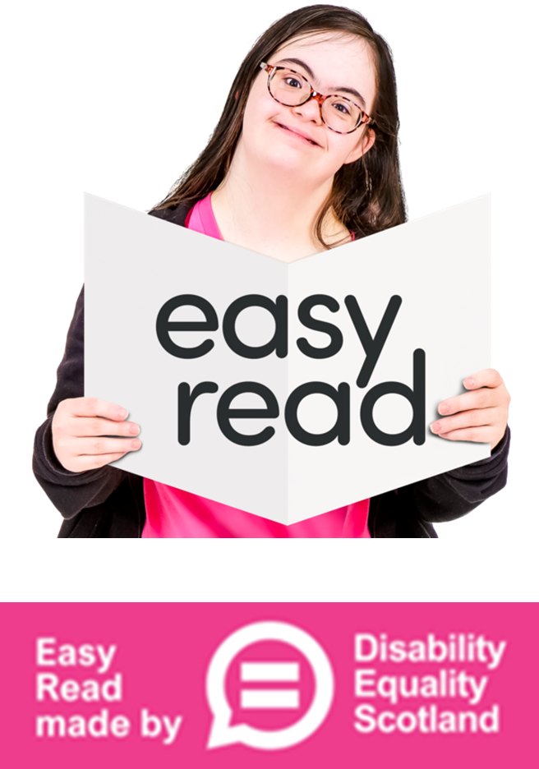
Easy Read Part 2



Making health fairer
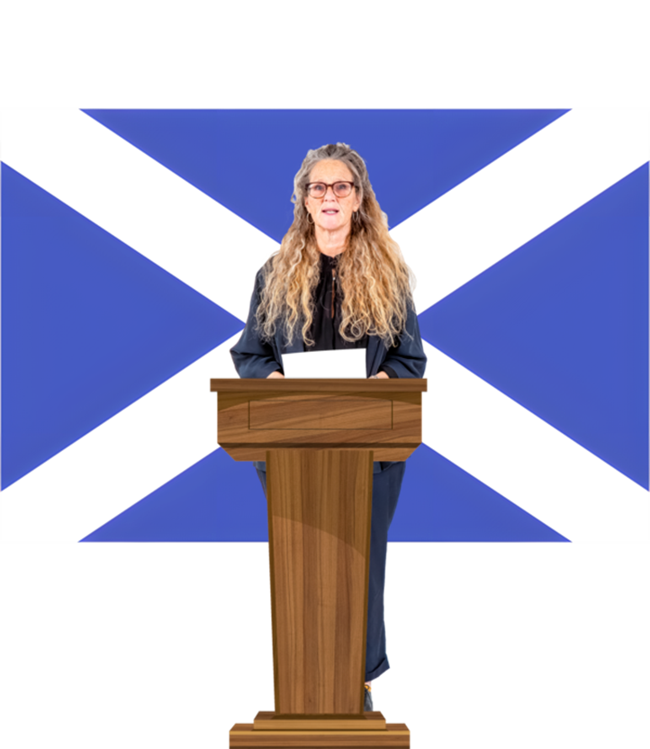 | The next Scottish Government must make sure that these 10 things happen to make health fairer.
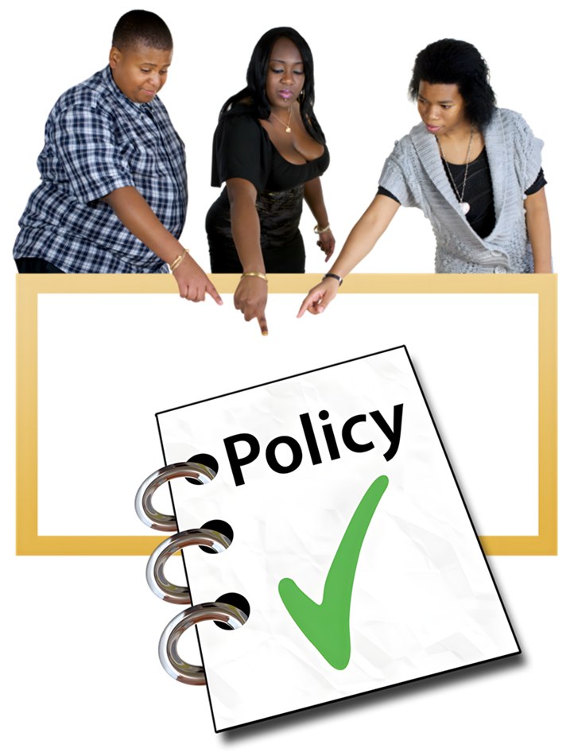 | 1. Make sure that human rights are planned into all the policies which are about public health.
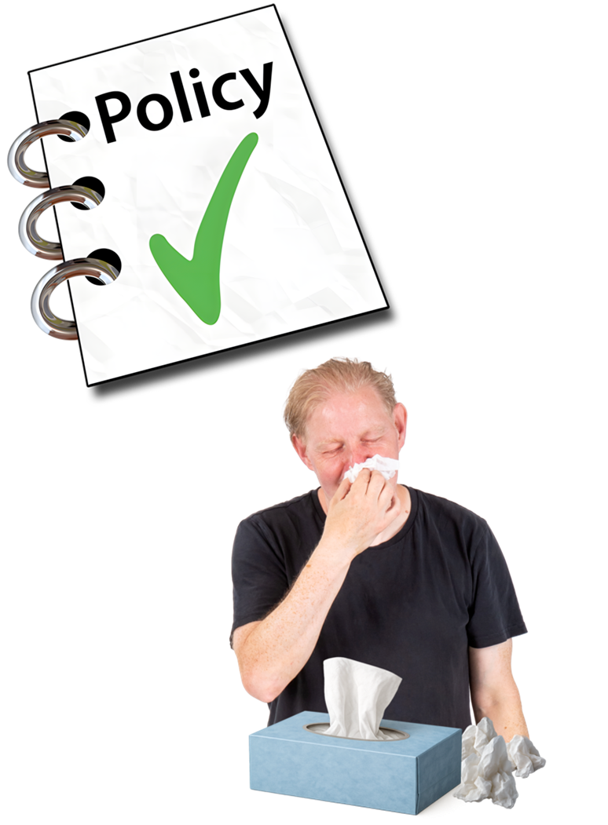 | Policies are documents that an organisation writes to show how it works and what will happen.  Public health means helping people to stay healthy and protecting everyone from illnesses.
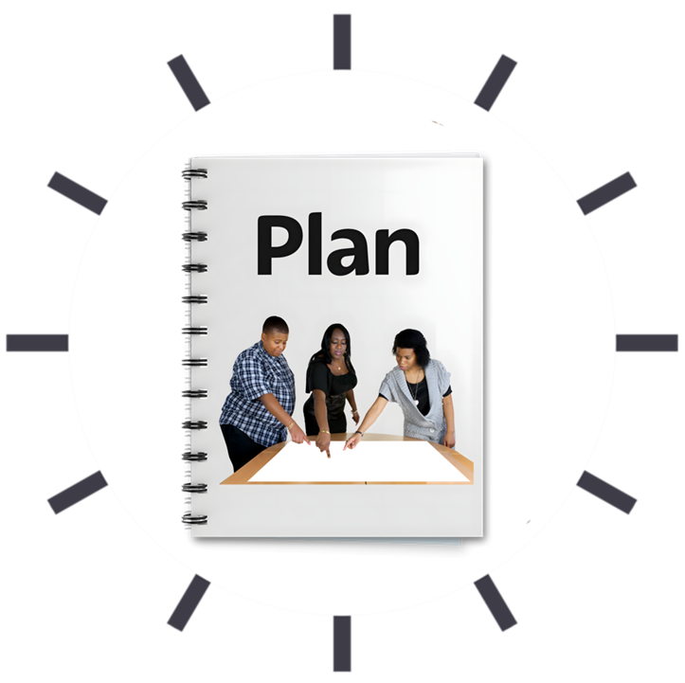 | 2. Make a new programme called the Mental Health and Capacity Law Reform Programme.  It will plan how to update laws to better protect human rights.
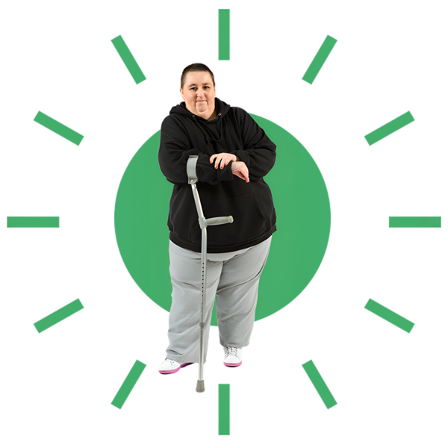 | 3. Change the way that social care happens in Scotland by planning it with human rights at the very centre.
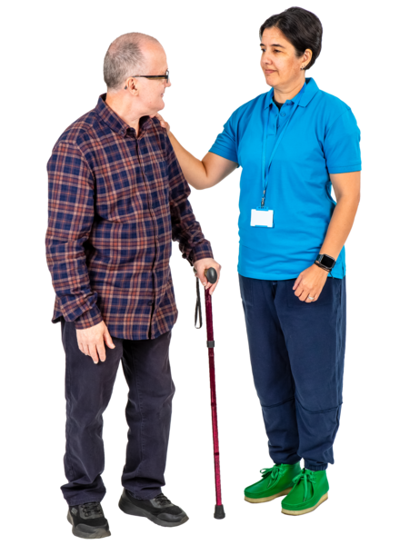 | Social care means services that support people with daily living so they can be as independent as possible.
 | 4. Give money for activities that help people with long term conditions with their mental health and wellbeing.
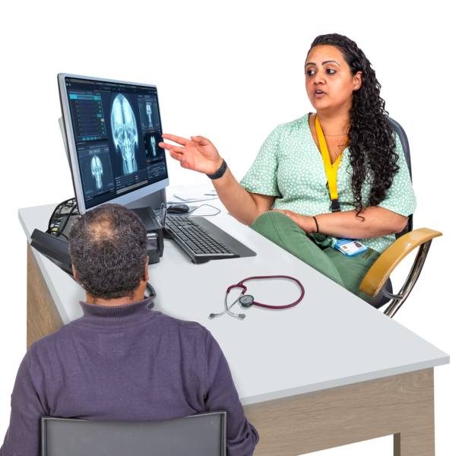  k | Long term conditions means illnesses that last for a long time and need managing with ongoing treatment.
 | Mental health and wellbeing means how well we cope with the ups and downs of life and how happy we generally feel.
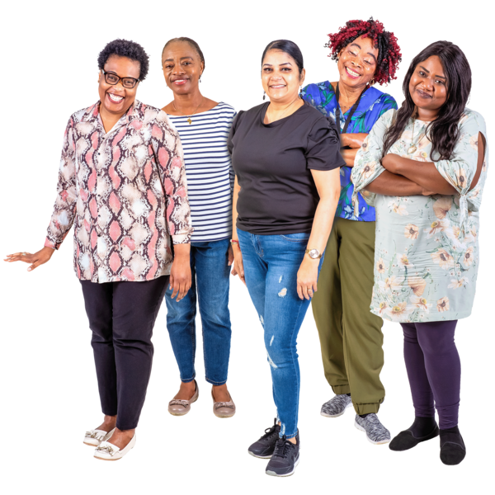 | 5. Make a new Scottish Institute for Women’s Health.
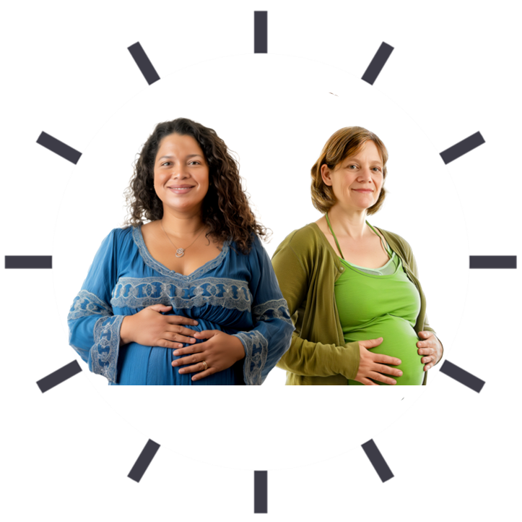 | 6. Design new pregnancy and maternity services by looking at what happened during the pandemic and putting human rights at the centre.
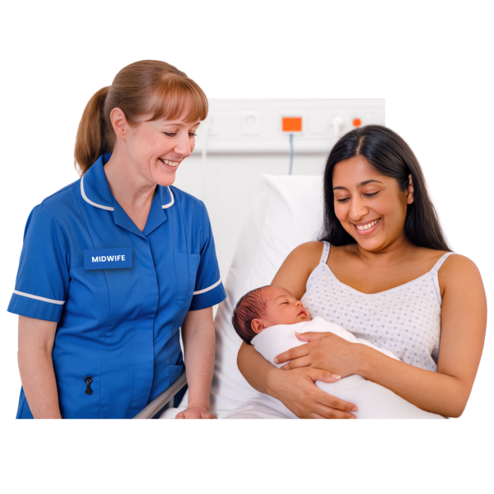 | Pregnancy and maternity services means the support you get from people like midwives and doctors:  - when you are pregnant  - when the baby is born  - while the baby is very young
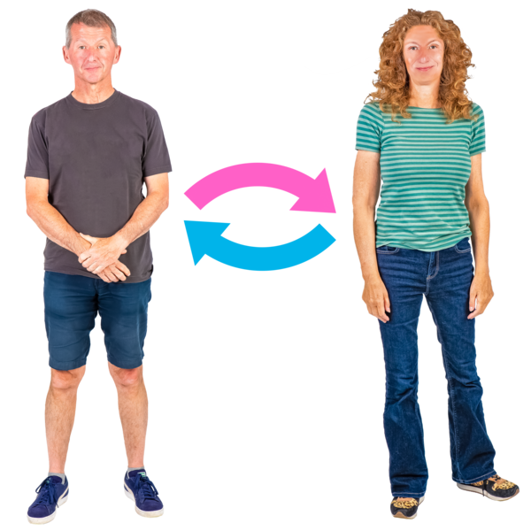 | 7. Have more and better healthcare for trans and non binary people.  Trans means you might feel that the body you were born into is not right for you.  This means you may want to change from being a man to a woman, or from a woman to a man.
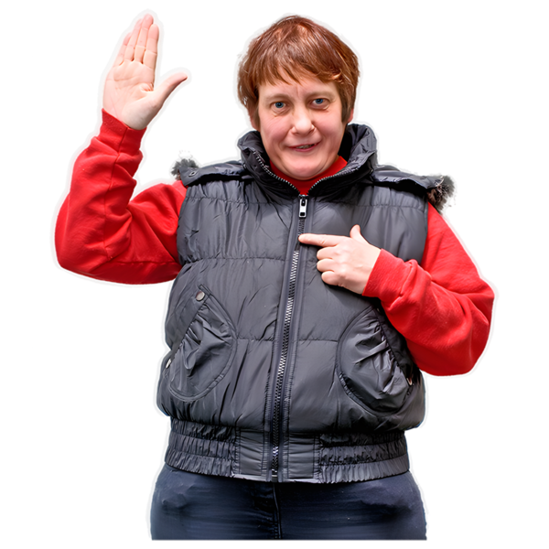 | Non binary means you do not see yourself as either a man or a woman.
 | 8. Carry on putting human rights at the centre of:  - the National Mission on drugs  - the Charter of Rights for People Affected by Substance Use  These are both works to support people whose lives are affected by things like drugs and alcohol.
 | 9. Offer COVID-19 booster vaccinations to unpaid carers.
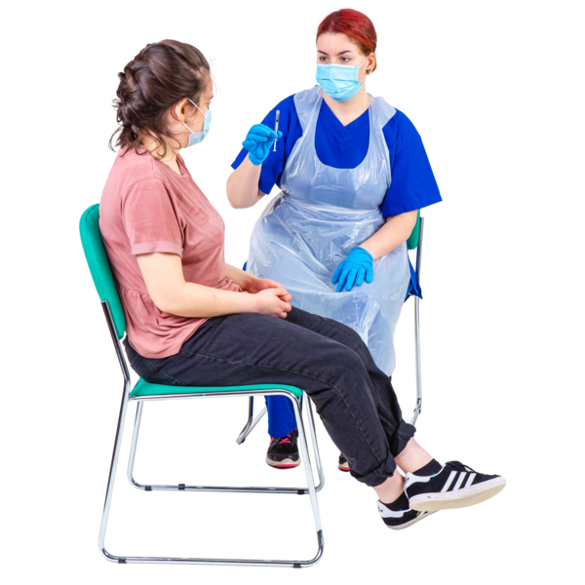 | COVID-19 booster vaccinations are usually injections to stop you getting very poorly from the COVID-19 virus.
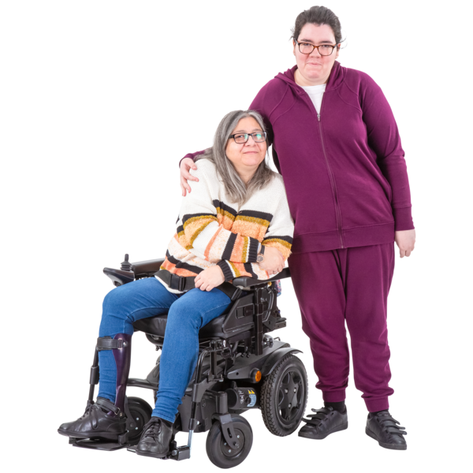 | Unpaid carers means anyone who cares for a friend or family member who cannot cope without their support.  They are not paid to do this.
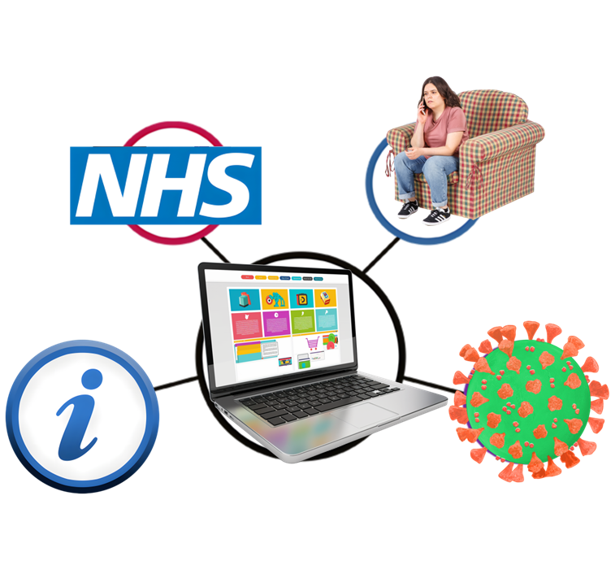 | 10. Make a hub for Long Covid in NHS Scotland.  A hub means an online centre to share support and information.
   | Long Covid means feeling ill with  Covid-19 symptoms long after the virus has gone.

Less poverty

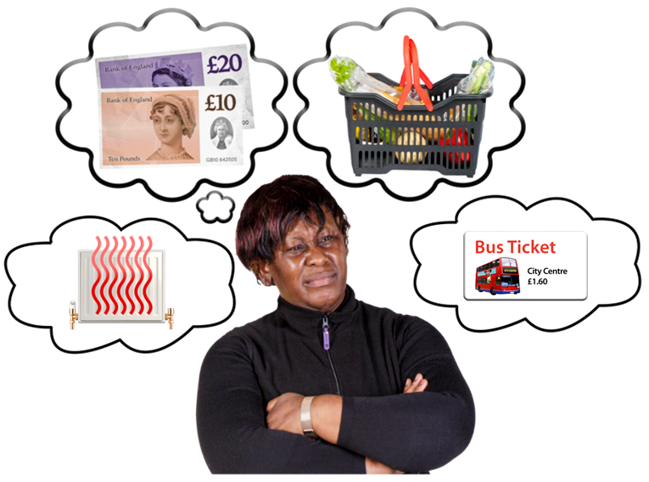 | Poverty means means not having enough money to pay for basic needs like food, clothes or heating.
 | The next Scottish Government must make sure that these 12 things happen for there to be less poverty in Scotland.
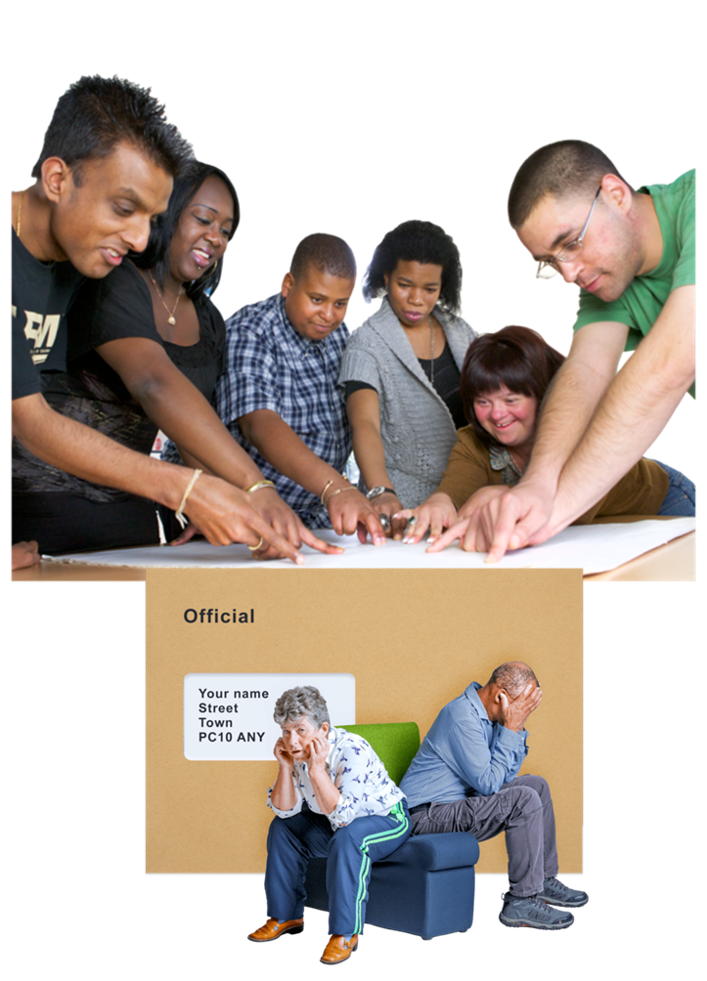 | 1. Work with organisations like local councils to look closely at human rights and how people’s debt is dealt with.
 | Debt means the money you owe to someone or to a business or bank.
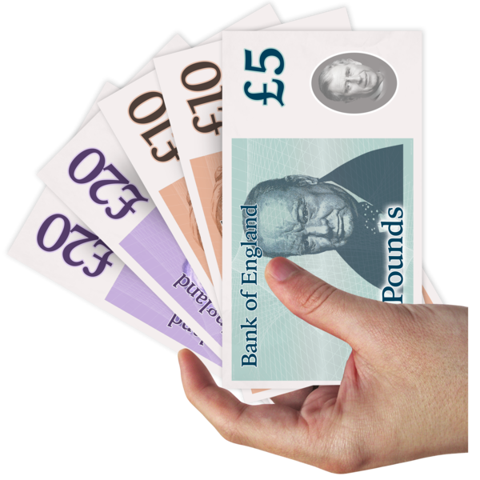 | 2. Straight away add more money to the Scottish Child Payment.
 | 3. Ask the UK Government to stop:  - the benefit cap  - the 2 child limit  Both these rules harm women, children and bigger families.
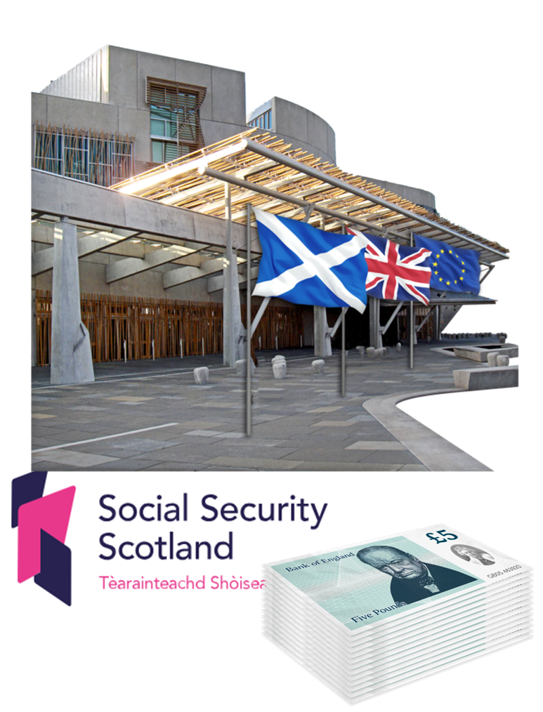 | 4. Make it easier for people to get the benefits that come straight from the Scottish Government.
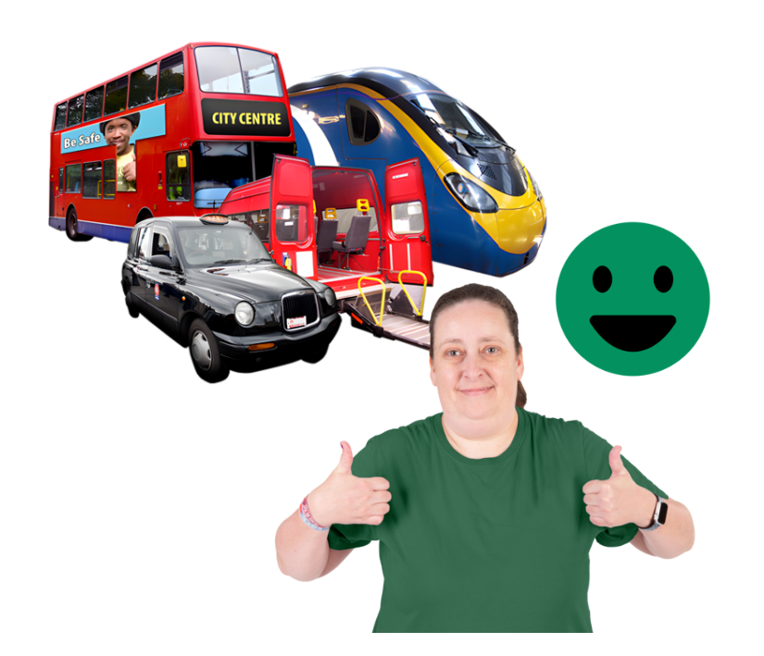 | 5. Make it easier for everyone to get around by:  - making transport like buses, trains and trams cheaper  - offering more free travel
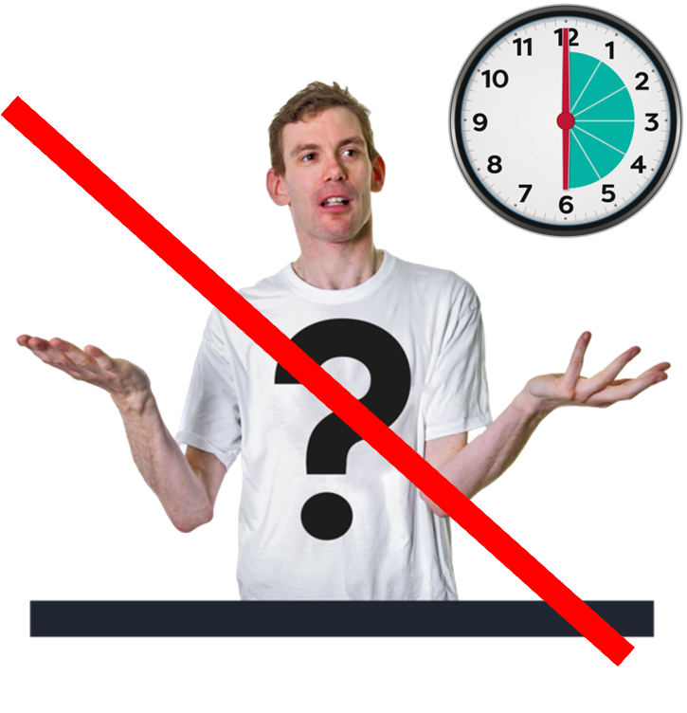 | 6. Make work fairer for everyone.  Get rid of work contracts that make workers feel unsure of their future.  Help everyone give and get the real living wage.
 | The real living wage is the amount of money we truly need to live on.
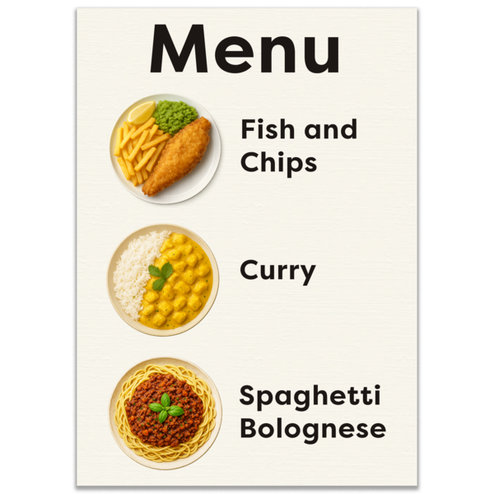 | 7. Give every pupil at primary and secondary schools free school meals.
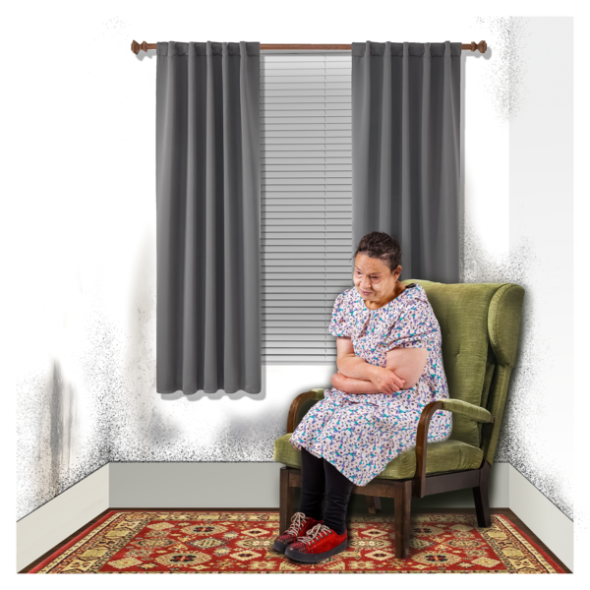 | 8. Help people who do not have enough money for basic things like money, clothes and heating.  Do this by putting more money into the Scottish Welfare Fund and other funds like this.
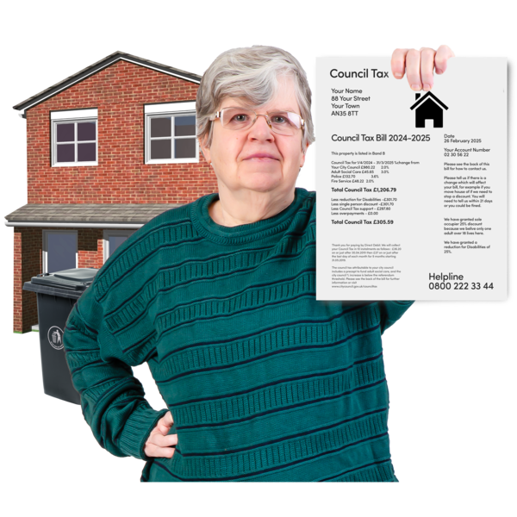 | 9. Change Council Tax so that people who live in homes worth more money have to pay more money.
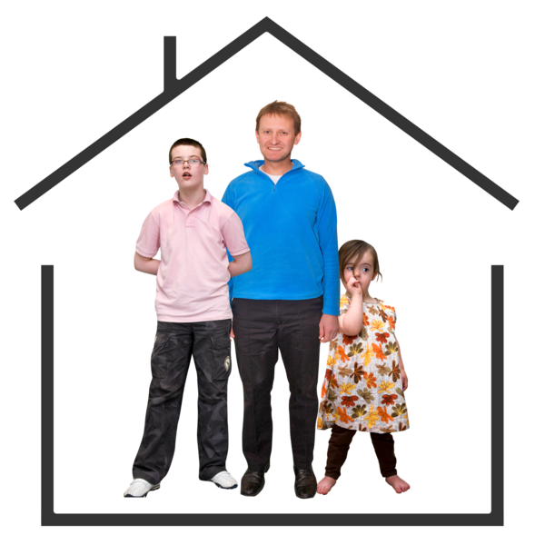 | 10. Make more social housing cheaper and more accessible so that families who do not earn much money are not under so much stress.
 | 11. Make sure people who are renting their homes from landlords also have:  - housing support  - the right accessibility
 | 12. Make a plan for people across Scotland to have the right to enough good food.

Disabled People’s Rights
 | The next Scottish Government must make sure that these 9 things happen to give disabled people in Scotland their rights.
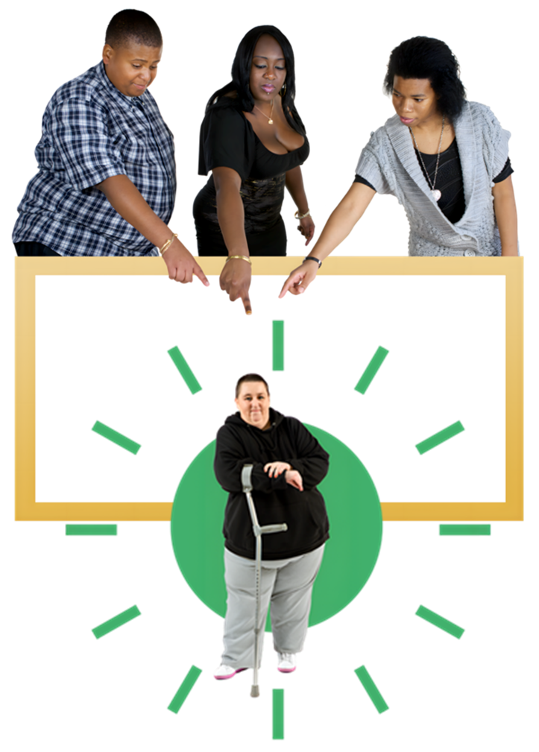 | 1. Make a programme which looks at better human rights and disability rights across government and public organisations like hospitals and police.
 | 2. Make an Accessible Information Standard.  This will tell government and public organisations like health centres and schools what they need to do to make sure that their information does not leave anyone out.
3. Make it easier for disabled people to access social security benefits.

Social security benefits means money to help people with everyday costs.

 | 4. Keep funding the Social Security Independent Advocacy Service and check how well it is working.
 | The Social Security Independent Advocacy Service is a free service for people with a disability.  It helps people with a disability to access and apply for Social Security Scotland benefits.
 | 5. Check that digital services have human rights in place.  Digital services means things you can access online or through technology, like a website or an app.
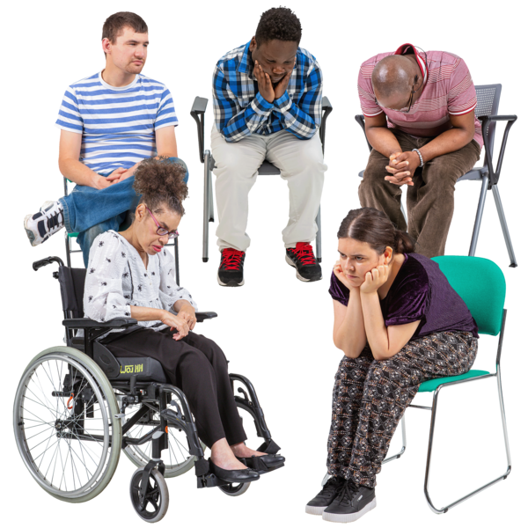 | Look to see whether disabled people and older people are left out of digital services.
 | 6. Make sure that all the government systems that people need to follow are:  - accessible by everyone  - on paper if needed  - checked for human rights
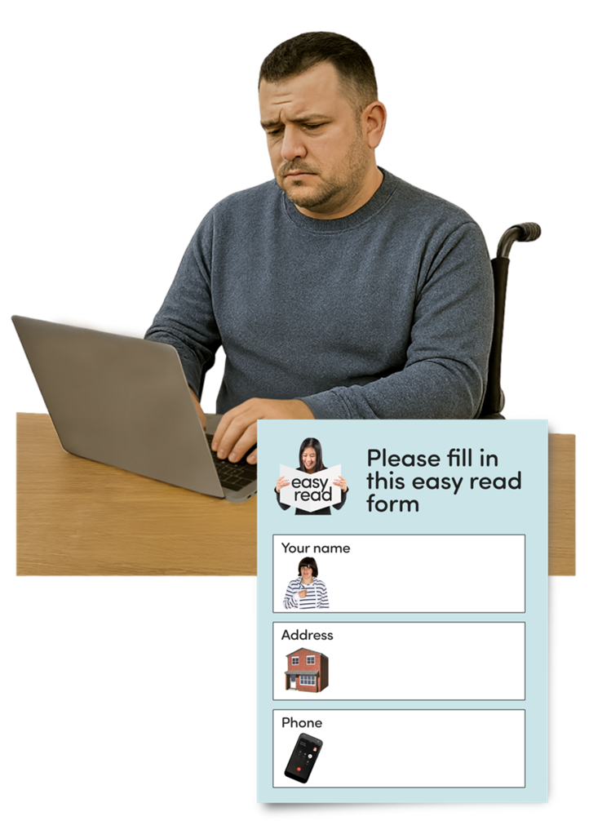 | In this document government systems means things like:  - applying for benefits  - filling in forms  - paying tax  - answering questions like ‘what do you think about crime in your area?’
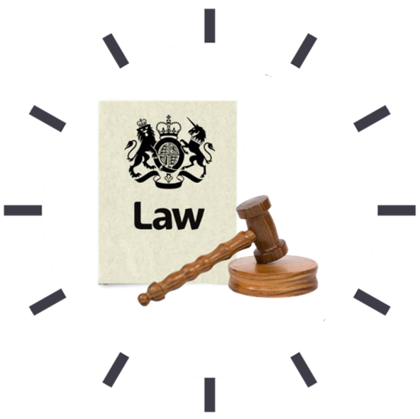 | 7. Carry on with work to make a new bill called the Learning Disabilities, Autism and Neurodivergence Bill.
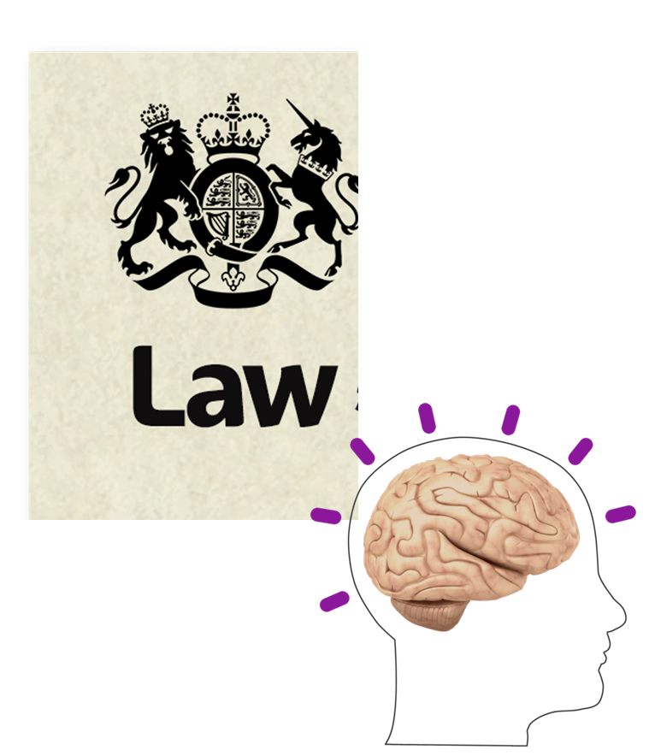 | A bill is a set of new laws.  This bill is about:  - learning disabilities  - autism  - neurodivergence
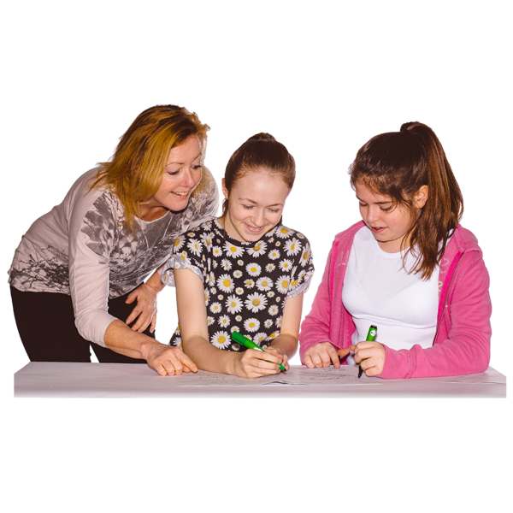 | Learning disabilities make it harder for some people to learn, understand or do things.
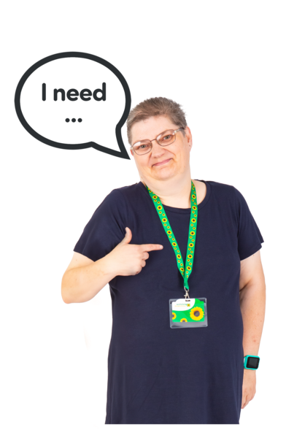 | Autism is a brain difference that can affect the way an autistic person:  - thinks  - communicates  - takes in information  - senses the world around them – like touch, light and sound
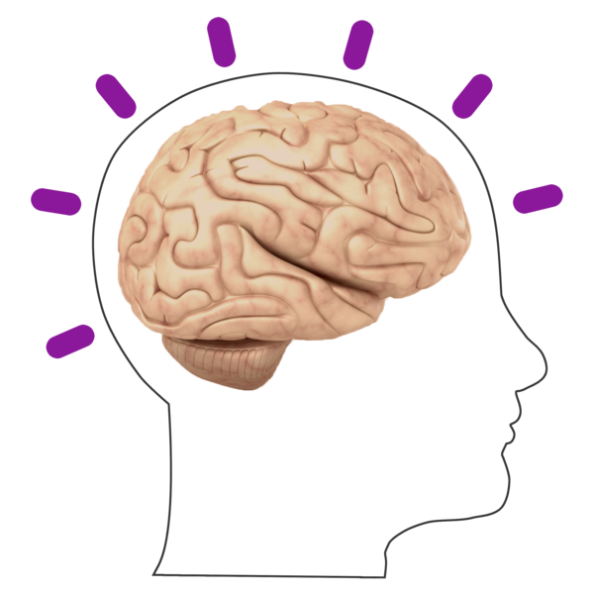 | Neurodivergence means people whose brains work differently to most other people.
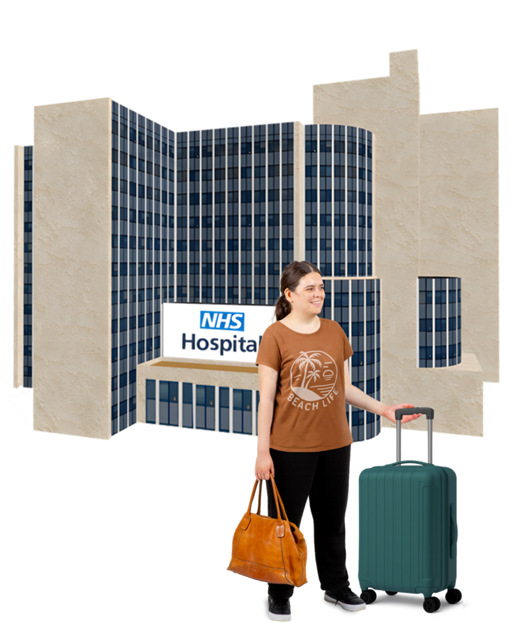 | 8. Work carefully with other organisations to make sure that these people can leave places like hospitals and move into good homes:  - people with learning disabilities  - people with mental health problems  - autistic people
9. Make new laws in Scotland to stop young people and children:

- being wrongly held by an adult
- put on their own in a harmful way

More of our priorities and our asks

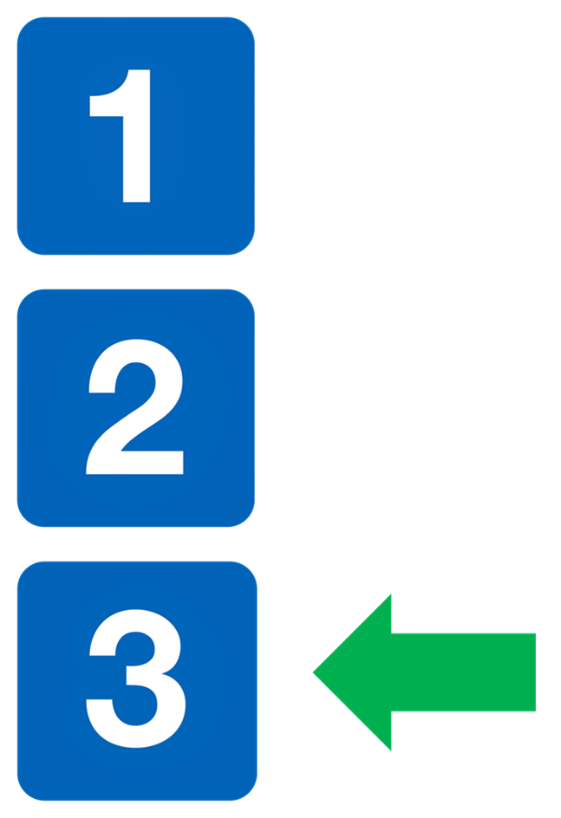 | This is the end of Part 2.  Please now read Part 3.



