

Our priorities and our asks for the next Scottish Government
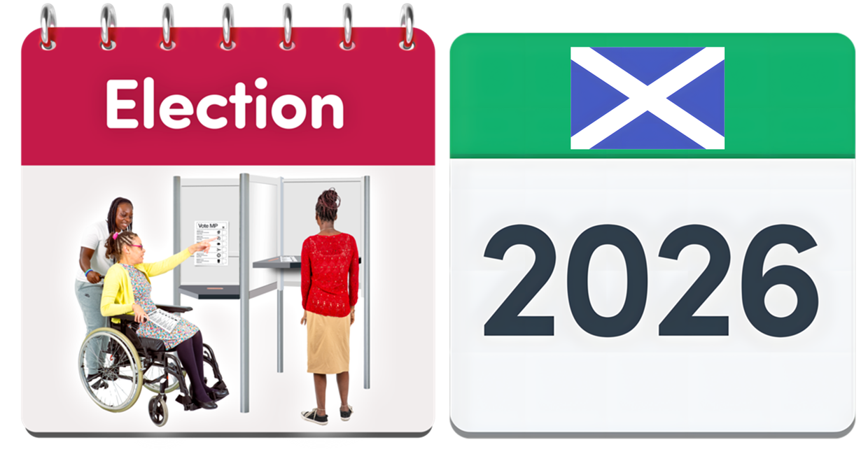
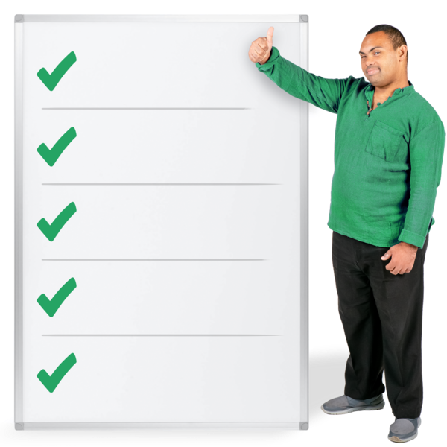



Easy Read Part 1



About this document
 | This is an Easy Read document.
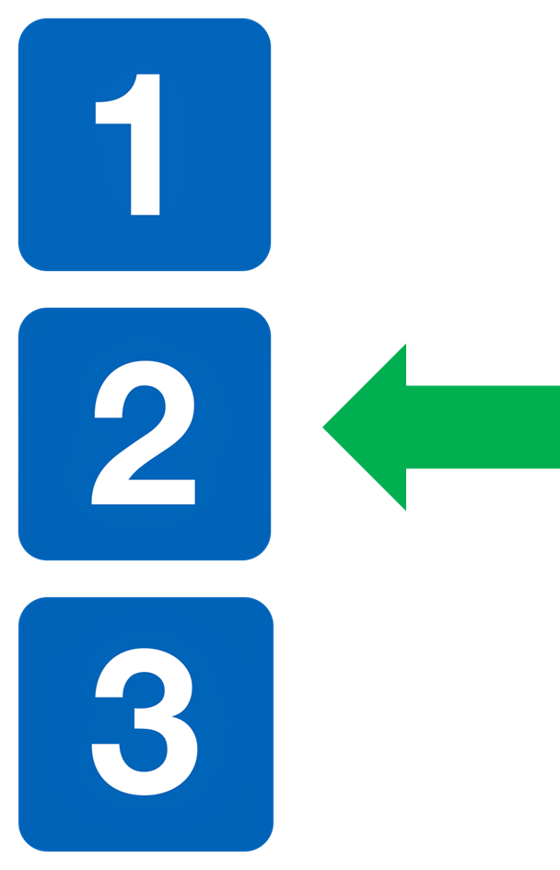 | This is Part 1.  There is also Part 2 and Part 3.
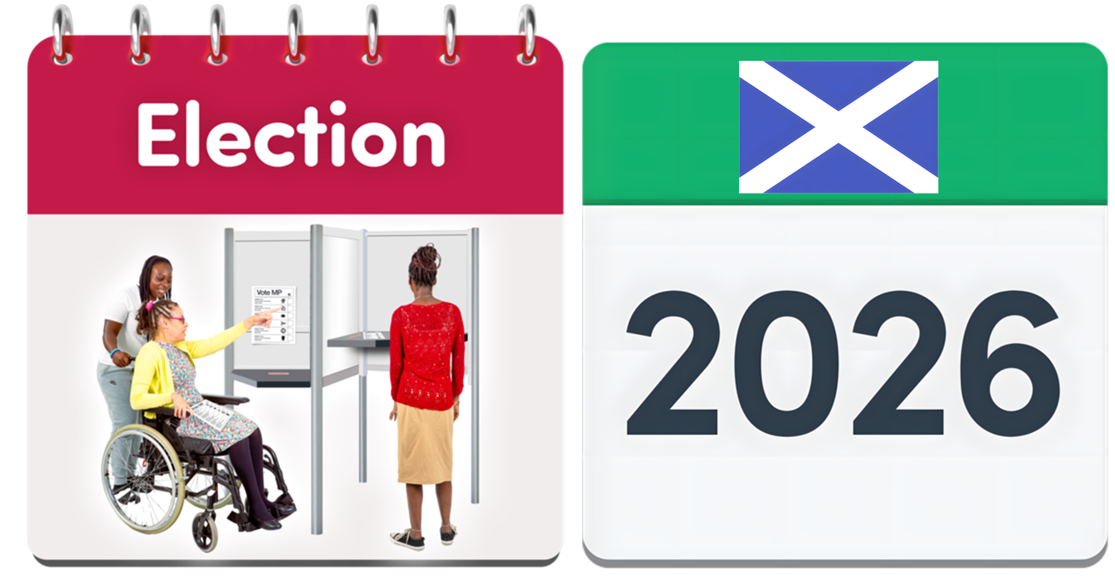 | In 2026 there will be an election to choose a new Scottish Government.
 | An election is when people vote to say who they want to lead their country.
 | This document is a list of the things Human Rights Consortium Scotland wants the next Scottish Government to do.
 | This list is also called our priorities and our asks.  Priorities and asks mean the important actions we think should happen next.

About Human Rights Consortium Scotland

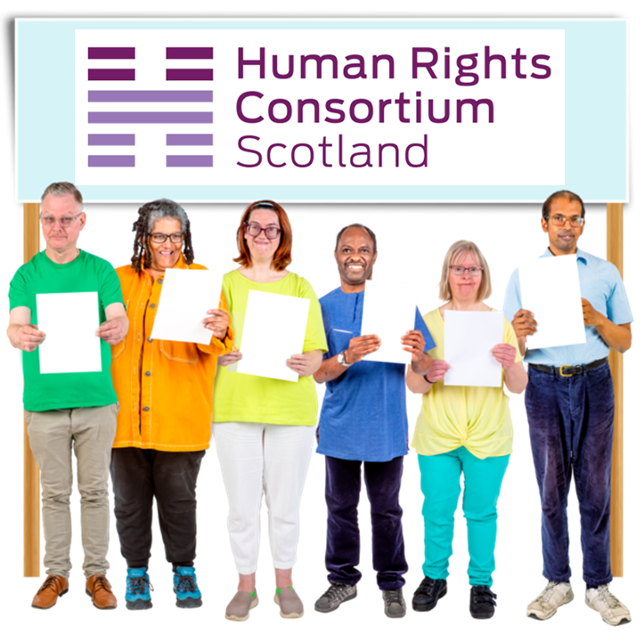 | Human Rights Consortium Scotland is an organisation which works to make human rights better in Scotland.
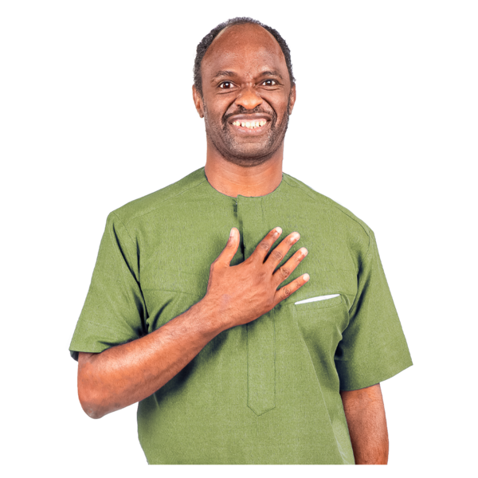 | Human rights means the basic rights and freedoms that belong to every person in the world.
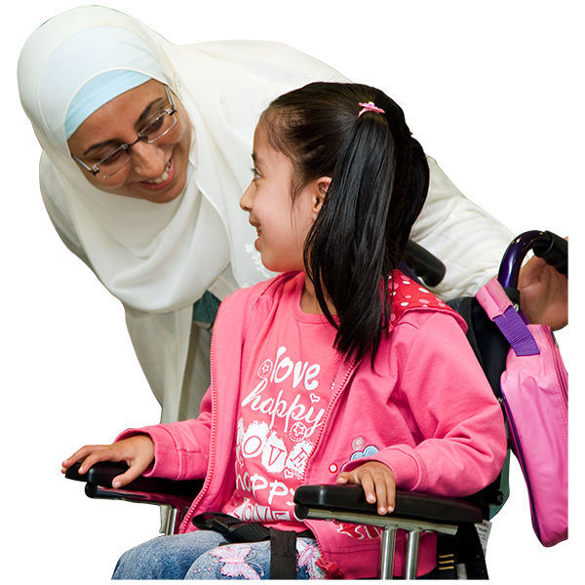 | They make sure that things like respect and dignity are there in all parts of our society.  Dignity means being seen as a whole person, with feelings and needs.
 | Human Rights Consortium Scotland is also called HRCS for short.

Putting human rights into law

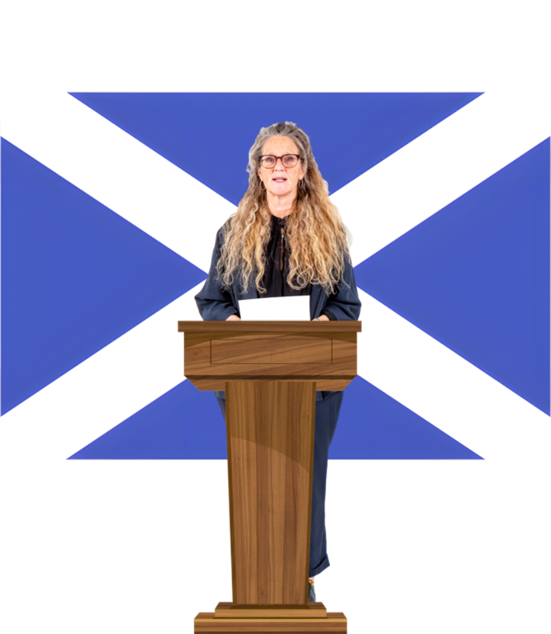 | The next Scottish Government must make sure that these 5 things happen.
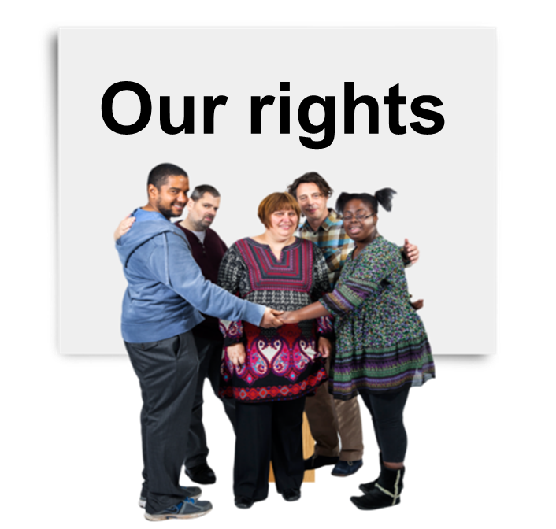 | 1. It must bring in a Scottish Human Rights Bill as soon as possible.
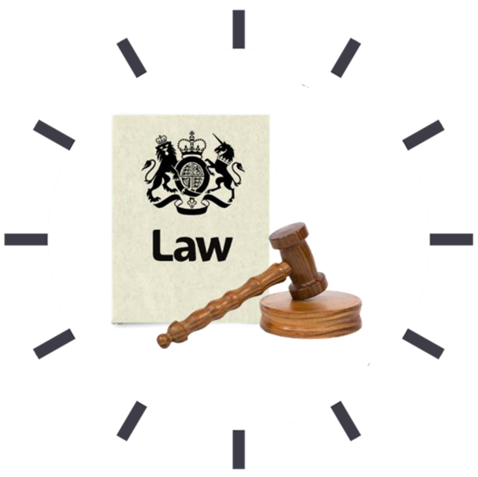 | A Bill is a plan for a new law.  Members of the Scottish Parliament discuss them to decide if they should become law.
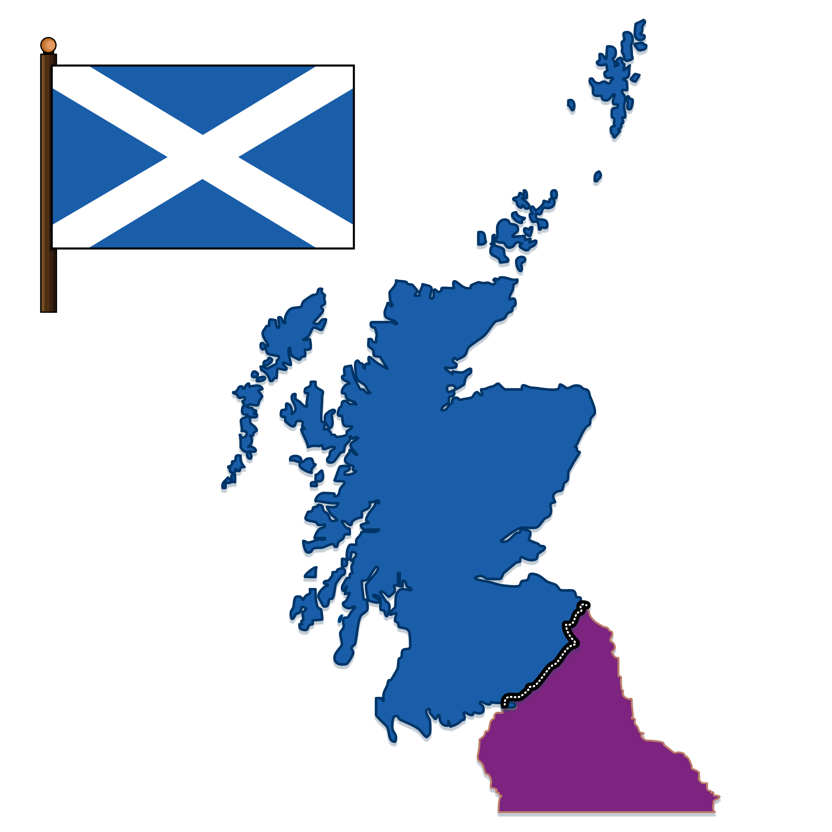 | The Scottish Human Rights Bill is a planned new set of human rights laws that we want to happen in Scotland.
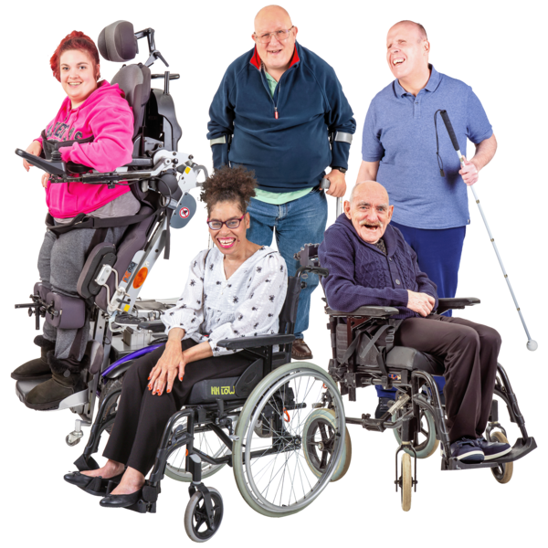 | 2. It must make sure that the Human Rights Bill includes people’s lived experiences.  Lived experience means the knowledge someone has because of the things they have experienced in their life.
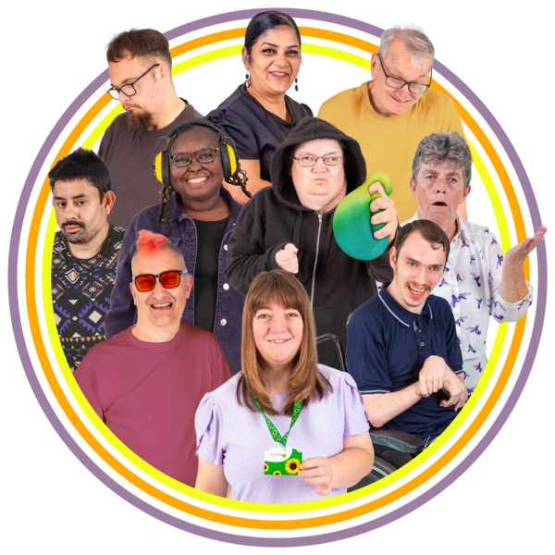 | It must listen to the lived experiences of everyone, including groups of people who are often left out of decisions – like carers and people who have survived abuse.
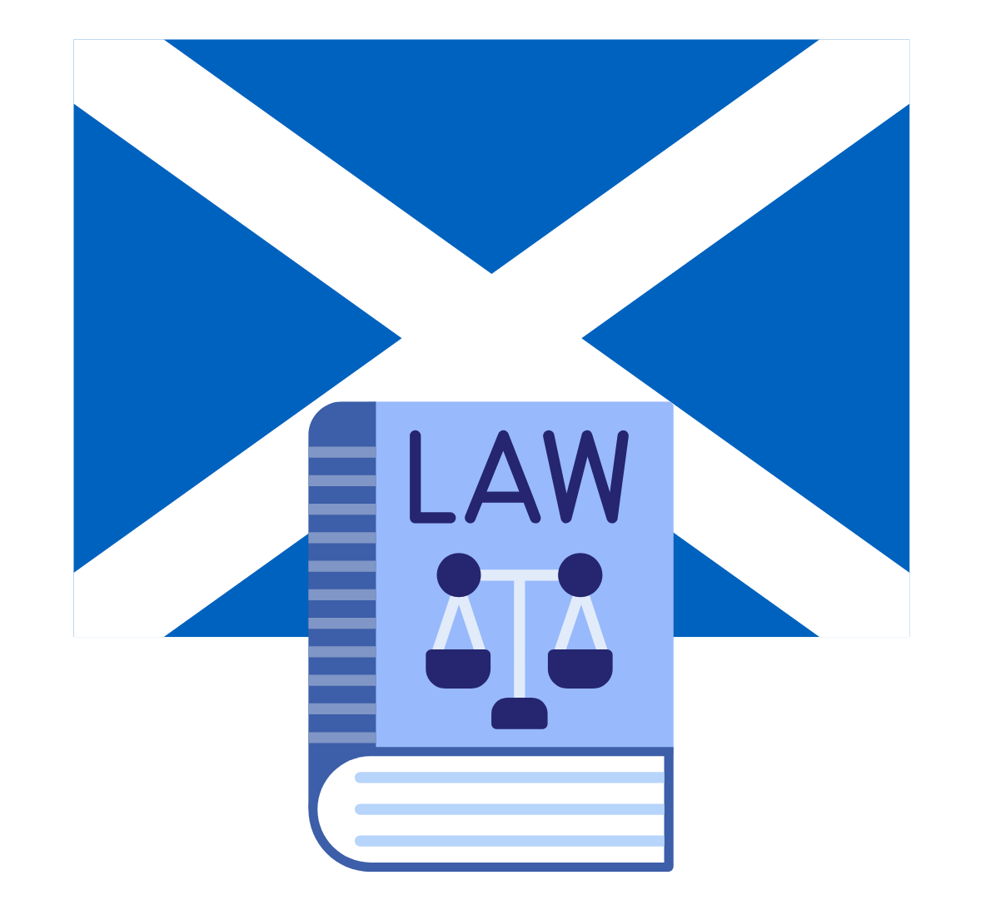 | 3. It must make changes to the Scotland Act to let the Scottish Parliament do more work on human rights.
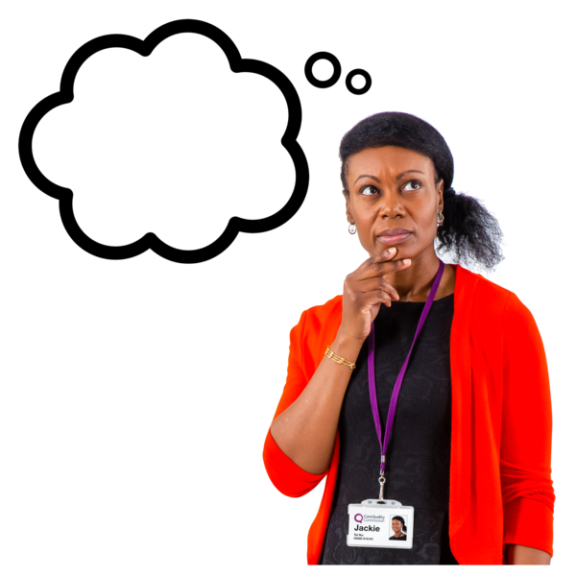 | 4. It must think of ways to work around the Scotland Act 1998 laws.
 | 5. It must make sure that any changes to the Human Rights Act 1998 say how important the international human rights are.  In this document international means agreed by many other countries.

Putting human rights into all we do

 | The next Scottish Government must make sure that these 7 things happen.
 | 1. It must check how well human rights are happening by following international human rights advice.
 | Especially putting these rights at the centre of life in Scotland:  - a home  - enough food  - clean water  - healthcare  - education  - work
 | 2. It must design and use a new tool called a Human Rights Tracker tool.  This tool will be a bit like New Zealand’s tracker tool.
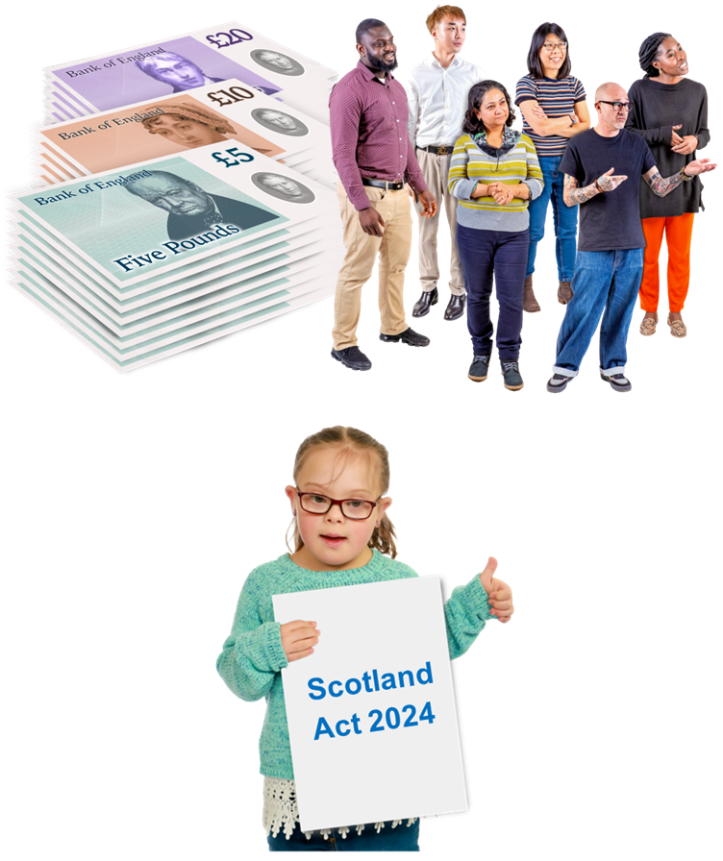 | 3. It must give enough money and staff to make sure that the UN Convention on the Rights of the Child happens in Scotland.  This is called the Scotland 2024 Act.
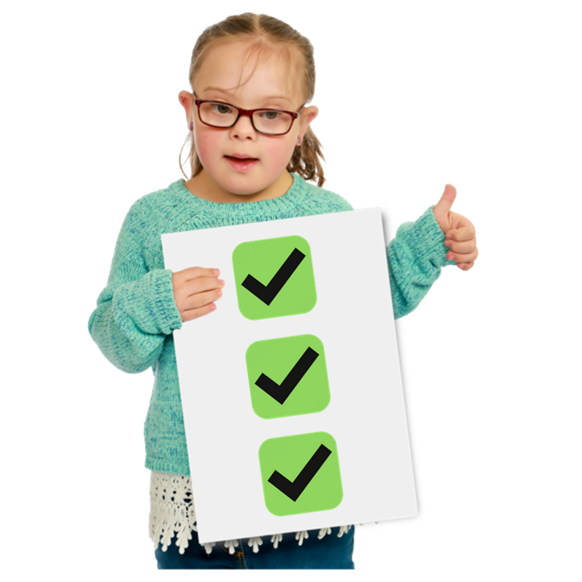 | The United Nations Convention on the Rights of the Child is a list of rights that many countries agree all children should have.
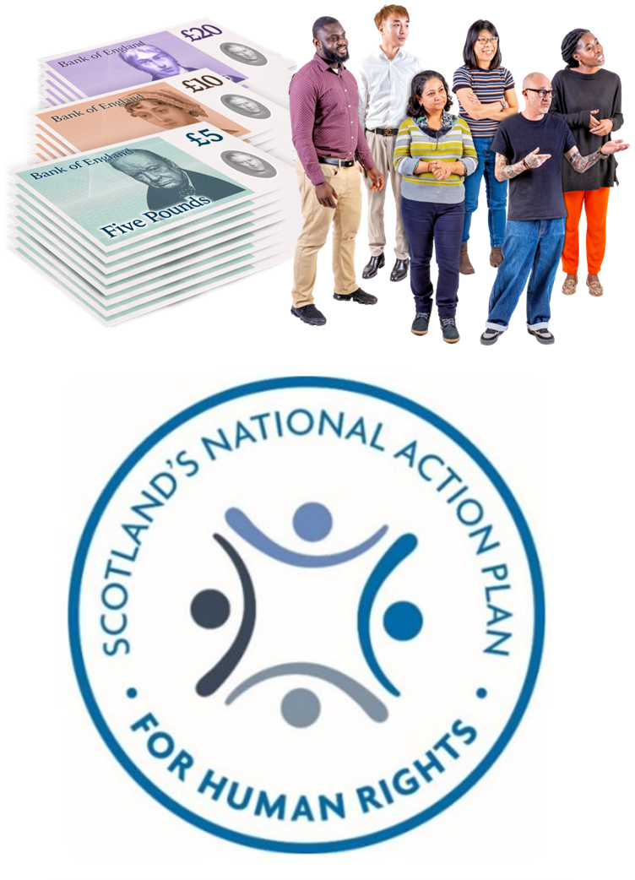 | 4. It must give enough money and staff to keep SNAP2 going.  SNAP2 is Scotland’s second Action Plan for human rights.  It must check how well the action plan is going.
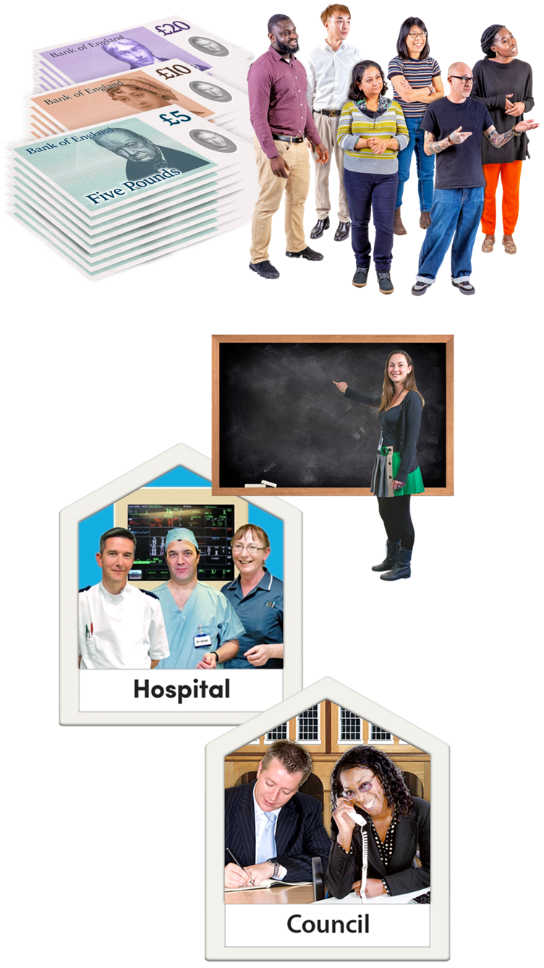 | 5. It must give enough money and staff to keep supporting public organisations like schools, hospitals and local councils.  The support will help make human rights better in everything they do.
 | 6. It must put human rights into its tax processes.
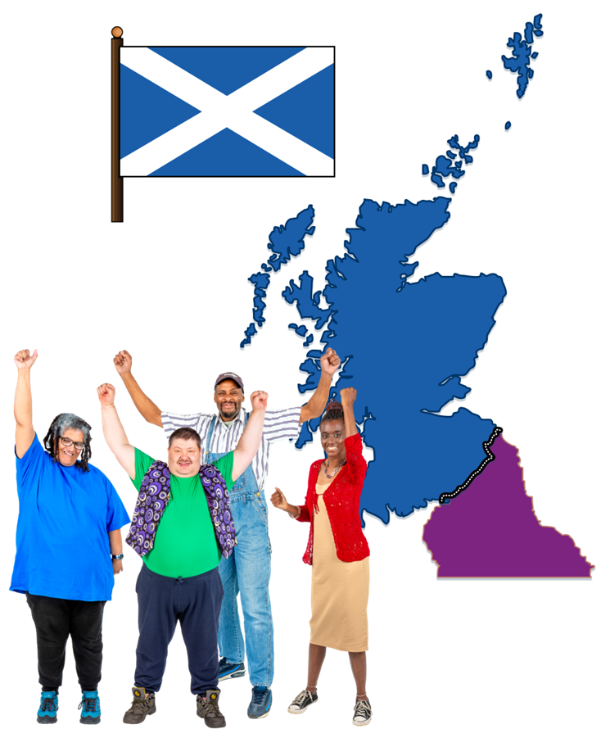 | 7. It must share and value all the work done for human rights in Scotland by other organisations and charities.

Making things fairer
 | The next Scottish Government must make sure that these 6 things happen.
 | 1. The new Scottish Government must collect facts and numbers about human rights and equality.  Equality means treating people fairly and giving people the same choices and chances.
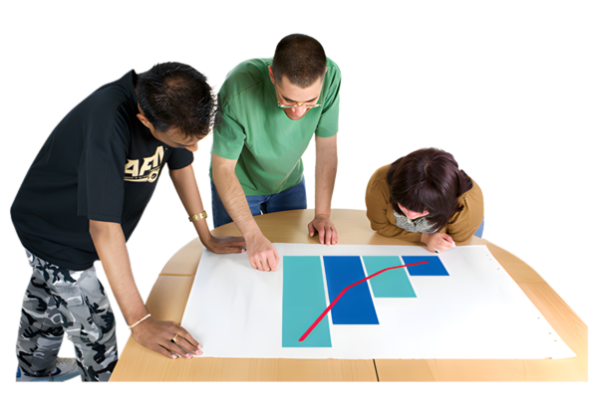 | 2. It must do a good job of getting this information from every government team.  It must use the information to see how well things are going and to decide what happens next.
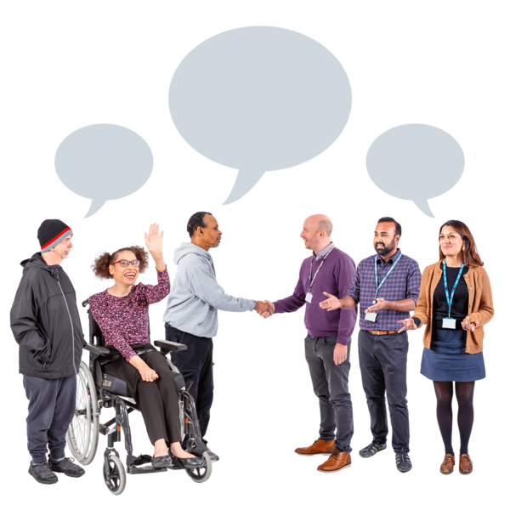 | 3. It must make sure that no one is left out in helping to make decisions about human rights.  This is called co-production.
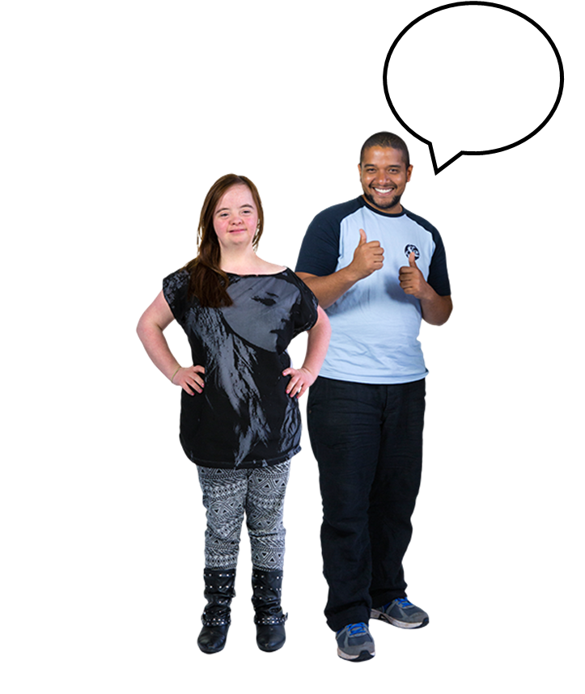 | 4. It must help more people speak up for other people who cannot, to get their human rights.  This is called advocacy.
 | It must make a new plan to help more organisations put human rights into their work, especially for:  - disabled people  - people from other communities who get left out of important parts of life
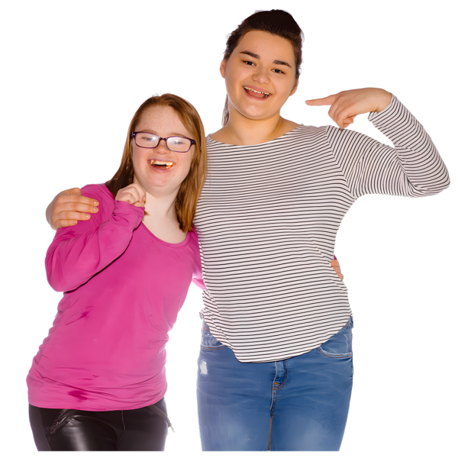 | 5. It must listen to children and young people’s opinions about decisions that will affect them.  This right is part of the United Nations Convention on the Rights of the Child.
 | 6. It must give the Scottish Human Rights Commission more powers and money.

More of our priorities and our asks
This is the end of Part 1.

Please now read Part 2.



